[](http://haydaysfife.co.uk/index.html)

Haydays 2015!!! Can you believe it! In January we’ll have been at the Town Hall for a whole year ..... and what a year it’s been!! The move has been such a great one for our organisation and the Town Hall certainly feels like home now.

We’ve had a number of special events throughout the year which have been very enjoyable and have kept us all on our toes. Most recently, as part of the October Luminate Festival, Haydays held two special events, both of which were a great success.

* 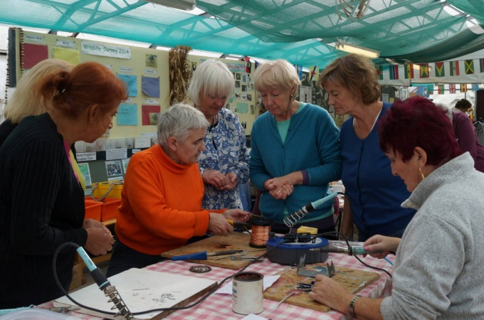‘Haydays in the Garden’, linking us with the St Andrews Botanic Gardens, was a fantastic experience enjoyed by all and definitely worth repeating in the Spring.
* Our recent Taster Day was extremely well attended and I know that many of you appreciated the chance to try something different. It was a really fun day which resulted in eight new members. A big warm Haydays welcome to each of you!!

The success of both of these events relied very much on the professionalism, flexibility and enthusiasm of our wonderful tutors and their commitment to Haydays and I really want to thank them for all they’ve contributed to another successful year.

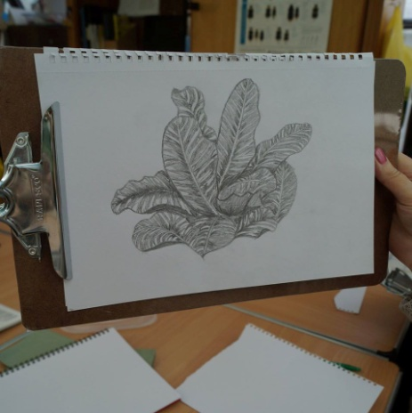Many thanks also to the Committee (and their helpers!) for all the organisation that went into both Luminate events and to our members for their cooperation and willingness to join in and go with the flow. With the exception of a couple of minor hiccups (not an easy task organising our 160 members!) it was all fantastic.

2014’s not over yet of course and we have a few things going on before we look forward to Haydays 2015.........

On December 9th, we have our Christmas celebration day which will kick off with our AGM. This will be our first AGM as a registered Scottish Charity!!! Many thanks to Helen Martin for filling in all the paper work and following it through to such a successful outcome.

This year’s AGM will see two members standing down from our committee after a two year term – our Chair – Janie Douglas - and our Treasurer – Maura Jack. Janie and Maura have both been amazing and leave behind big shoes to fill! However, on a positive note, we have several Haydays members who have indicated an interest in becoming more involved as Committee members and their names will go forward for election along with current Committee members who are putting themselves forward for re-election.

Haydays strength as you know, is that it is run by the members for the members and that means us all taking responsibility for the smooth running of our organisation. The committee is a strong one and we are in a healthy position re. membership and finance. Now is the time to consolidate and build on what we already have achieved. If you wish to volunteer for the committee or if you know someone who would make a great Committee member, fill in one of our nomination forms.

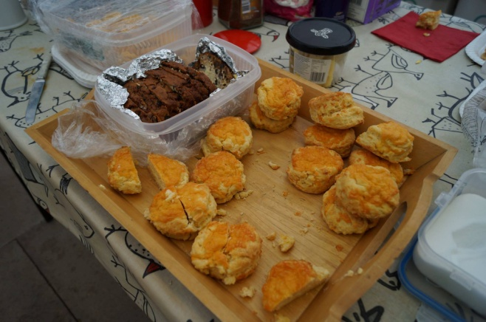If being part of a Committee isn’t really your thing, perhaps a more practical way of supporting Haydays would suit you better? You would, for example, be greeted with open arms by the volunteers who currently organise, supply and run our Haydays cafe. Volunteer numbers are increasing but there’s always room for more. More volunteers mean that everyone can enjoy the Haydays experience, rather than a small group of members feeling so over-committed that classes are missed or given up altogether. Helping out once in a while wouldn’t demand much of your time and it would be very much appreciated. If you haven’t yet put your name down for soup making or baking or serving or helping in the kitchen (either setting up or clearing away) or helping to serve lunch, then 2015 could be your year!! Go on! You know you want to!

The highlight of our Christmas celebrations this year will definitely be ‘Cinderella on a Budget’ – our first Haydays panto since we left the Byre! Wendy Quinault deserves our most grateful thanks for not only suggesting the idea but following it through with such professionalism and enthusiasm. It’s really funny and the costumes, thanks to Kirsty, Catherine and the rest of the team are works of art! If you’ve been involved in the panto preparations in any capacity at all – thank you! I just can’t wait to see it!!

Haydays festivities are always amazing and our banquet-style extravaganzas are fast becoming the stuff of legend! We Haydays members certainly know how to party! Over the next two/three weeks, sign-up sheets will be available for you to fill in with your food, drink or goody contribution to our Christmas celebration on the 9th. We are also planning to raffle a Christmas Hamper for charity. All items – big and small – will be gratefully received. Between now and the 9th, could you all please:

* 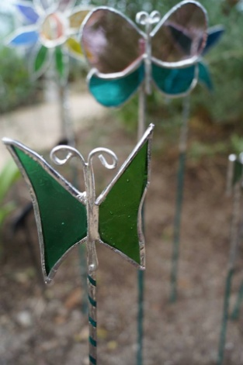bring a contribution for the Christmas Charity Hamper.
* buy tickets for the Christmas Charity Hamper.
* fill in the sign-up sheet saying what food, drink or goody you will be

bringing on the 9th

* come and support the AGM and enjoy the day with all your

Haydays friends.

With this letter is the next 6 week block of classes starting on January 13th. We have 3 new classes - Beginners’ Stained Glass, An Introduction to Patchwork/Quilting and Kurling! Sounds exciting!! Please read the notes enclosed to find out more.

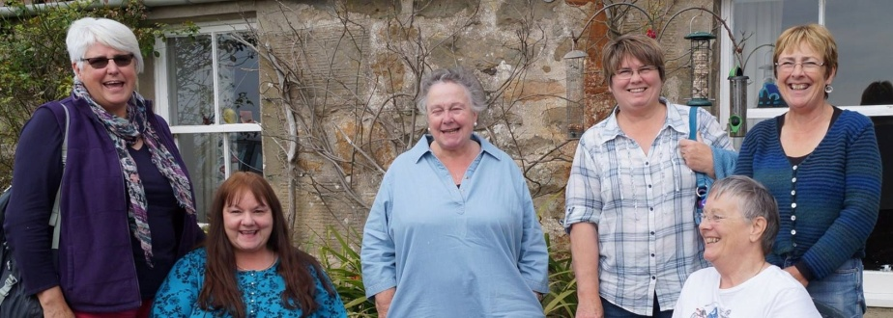This will be my last newsletter as Chair and I would like to take this opportunity of thanking all of you for your support and encouragement - not only to me but to the whole committee. Helen, Issi, Patsy, Janette, Liz, Maura and Roz have been wonderful to work with and I shall miss our long committee meetings which were always accompanied by great cakes, wonderful baking and many laughs!

Two years ago in February, when they told us that Haydays was no more, was a terrible day but thanks to all your hard work, support and enthusiasm Haydays is even stronger today than it was at the Byre. We are a unique group in so many ways and this was recognised by our award of charitable status and also by becoming category one members of Age Scotland.

I will still be around and the committee have asked me to take on a new role in developing community links for Haydays and reviewing how we can grow as a community organisation. I may also even take a few classes!!

Once again thank you all so much from me and from all the committee and we wish you a very Merry Christmas and a healthy and happy 2015.

Janie Douglas, Chair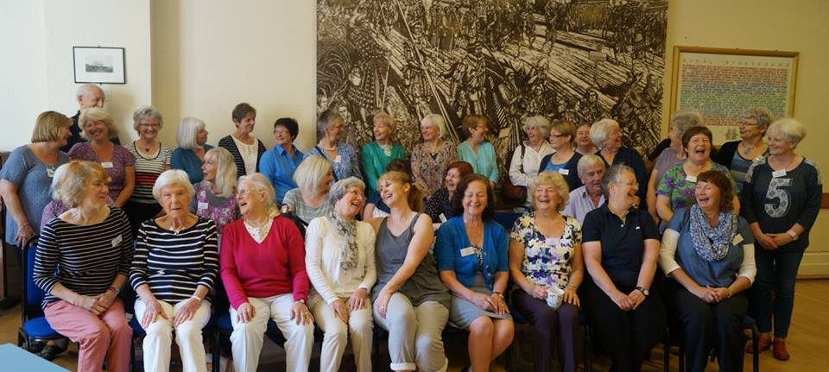

C:\Users\Roz\AppData\Local\Microsoft\Windows\Temporary Internet Files\Content.IE5\3ZVMAXLB\MC900092641[1].wmfC:\Users\Roz\AppData\Local\Microsoft\Windows\Temporary Internet Files\Content.IE5\7SZP6B59\MC900092677[1].wmfC:\Users\Roz\AppData\Local\Microsoft\Windows\Temporary Internet Files\Content.IE5\S43SAUIZ\MC900250786[1].wmf



**Dates for Haydays in 2015**

C:\Users\Roz\AppData\Local\Microsoft\Windows\Temporary Internet Files\Content.IE5\9SCU5WU9\MC900156753[1].wmf

**Block 3**: January 13th - February 17th **(6 WEEKS)**

**Block 4**: February 24th - April 21st with a 2 week Easter break on the 7th and 14th April **(6 WEEKS)**

**Block 5**: April 28th - June 2nd **(6 WEEKS)**

**Summer Celebration:** June 9th

**Please note:**

Haydays closes early for summer this year as new windows are being fitted at the Town Hall and the building is closed for bookings from the 15th June 2015